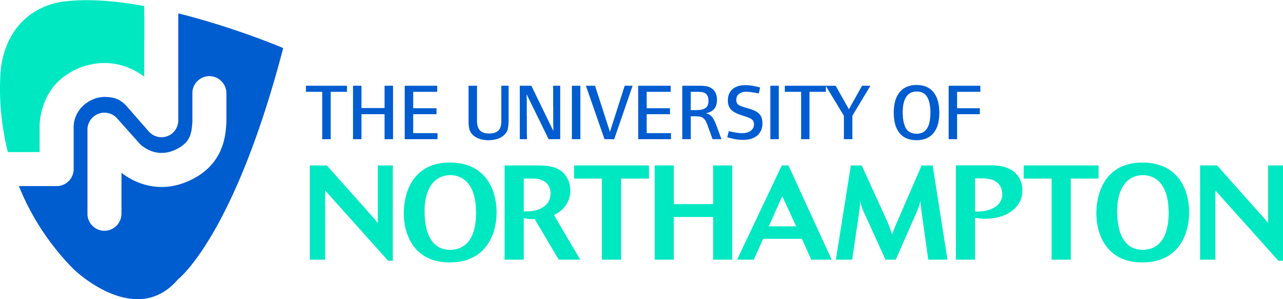

Northampton Electronic Collection of Theses and Research (NECTAR)

Author Licence

Name:

School and Division:

Title of work:

Thank you for depositing your work(s) in NECTAR.

By depositing this work, you agree to the Terms and Conditions of this non-exclusive licence:

- You are free to publish this work or works elsewhere in their present or future versions.

- You confirm that:

a) you are the copyright owner and/or have the right to grant us this licence

b) the work is original and to the best of your knowledge does not infringe anyone’s copyright.

c) the work does not violate or infringe any UK law.

- We agree to:

a) add the work to the repository so it is freely available online for the lifetime of the repository

b) convert it if possible to ensure it can be read by computer systems in the future.

- We reserve the right to remove the work for any legal or administrative reason
Terms and Conditions:

The Repository’s Rights and Responsibilities

1. NECTAR:

1.1 May distribute copies of the work(s) (including any abstract) worldwide, in electronic format via any medium for the lifetime of the repository for the purpose of free access without charge.

1.2 May electronically store, convert or copy the work(s) to ensure their future preservation and accessibility.

1.3 May incorporate metadata or documentation into public access catalogues for the work(s).

1.4 Shall retain the right to remove the work(s) for professional or administrative reasons, or if they are found to violate the legal rights of any person.

1.5 Shall not be under obligation to take legal action on behalf of the depositor or other rights holders in the event of infringement of intellectual property rights or any other right in the material deposited.

1.6 Shall not be under obligation to reproduce, transmit, or display the work(s) in the same format or software as that in which it was originally created.

Software

2.1 Copyright in additional data, software, user guides and documentation to assist users in using the work(s) shall belong to NECTAR on behalf of The University of Northampton and any other parties that NECTAR may choose to enter into an agreement with to produce such materials.

2.2 While every care will be taken to preserve the physical integrity of the work(s), NECTAR shall incur no liability, either expressed or implicit, for the work or for loss of or damage to any of the work(s) or associated data.

Definition & Terms

3. In this agreement: ‘Work’: means each item being deposited including any abstract, text, images and related data.

‘NECTAR’ and ‘repository’ mean any service provided by the University of Northampton to permit third parties to access electronic materials at no charge and which follows the principles of Open Access outlined in the Bethesda Statement:
(see http://www.earlham.edu/~peters/fos/bethesda.htm.)

Depositor’s Declaration

4. I hereby grant to the Northampton Electronic Collection of Theses And Research (NECTAR) a non-exclusive licence on the terms outlined below. I warrant that:

  - I am the owner of the copyright for the whole work(s) (including content & layout) or am duly authorised by the owner(s), or other holder of these rights and am competent to grant under this agreement, a licence to hold and disseminate copies of the material.

  - The work(s) are not and shall be in no way a violation or infringement of any copyright, trademark, patent, or other rights whatsoever of any person.

  - That if the work(s) have been commissioned, sponsored or supported by any organisation I represent, that I have fulfilled all of the obligations required by such contract or agreement.

SIGNATURE: …………………………………………………………. DATE: …………………………

Embargo:
An embargo is a specified period of time during which an item’s full content will be suppressed (i.e. the bibliographic data will be visible, but not the item itself). Under normal circumstances no embargo period will be applied.

Duration of embargo (e.g. 6 months): …………………………………………………..……

Reason for embargo:
The item is subject to a publisher’s embargo period □
The item contains information provided in confidence □
Releasing the item would cause substantial prejudice □
to commercial interests
Other reason (please state) □

